**MILESTONE DELIVERY PROTOCOL:**

Once a determined task is completed the developer will must inform of it via the TESTING board in HacknPlan, there it will be needed the requirements established by the QA team and each leads of other areas to be approved.

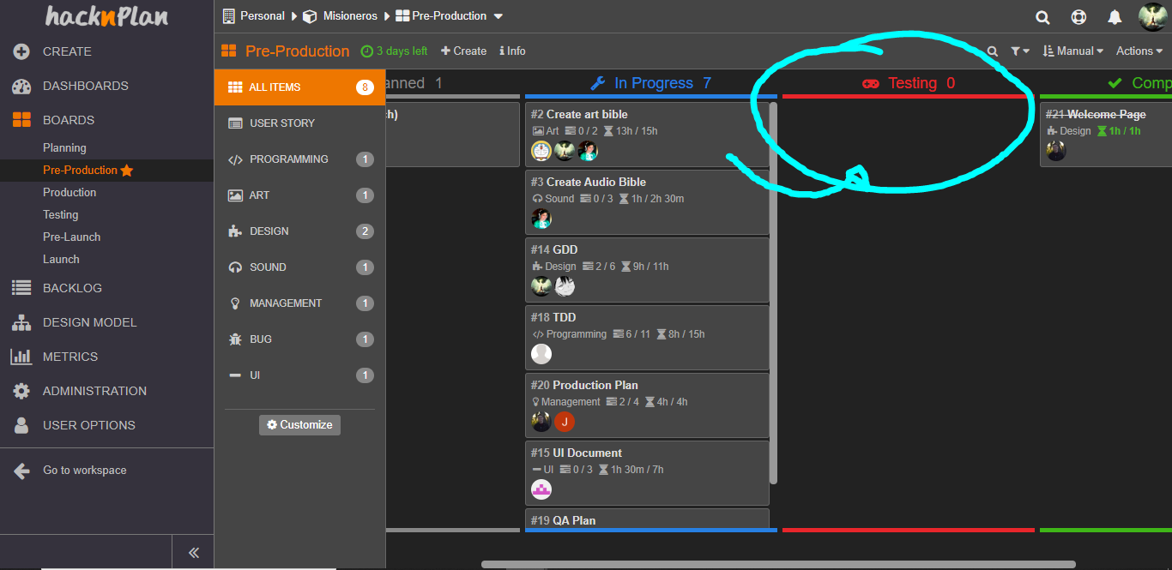

**Design task requirements:**

|  |  |
| --- | --- |
| Requirement | Performs/Doesn't performs |
| It maintains a cohesive performance with the actual design of the game. |  |
| It doesn’t requires a large new system in-game. |  |
| Doesn’t breaks any other system implemented before. |  |
| Users will realize (understand) that the action is linked to the active object, that is, that the object serves to execute the action you want to execute. |  |

**Art task requirements:**

|  |  |
| --- | --- |
| Requirement | Performs/Doesn't performs |
| The object/unit respects the color palette (saturation, brightness and tone). |  |
| It has the right size respect the others tiles/assets/props. |  |
| It has been modified with the photoshop’s “Brush Strokes” effect. |  |
| It does not breaks the immersion of the player in-game. |  |
| The objects look like what they are for (affordance). |  |

**Code requirements:**

|  |  |
| --- | --- |
| Requirement | Performs/Doesn't performs |
| It compiles without any relevant error. |  |
| No functions definitions on .h files, definitions MUST be on .cpp files. |  |
| We MUST comment functions in the .h file, at least explain in a line what the function does and what the parameters are. |  |
| The names of functions parameters MUST clearly state what they are. |  |
| Variables MUST be identified with a clear/related name and/or a comment. |  |
| When declaring a class, the code inside must follow this rules, constructor and destructor declarations, variable declarations, function declarations. |  |

**UI requirements:**

|  |  |
| --- | --- |
| Requirement | Performs/Doesn't performs |
| The new interface is consistent in control, colour, typography and dialog design (e.g. large blocks of text are avoided, no abbreviations) and as non-intrusive as possible. |  |
| The added object is intuitive and the meanings are obvious and perceived as a part of the game. |  |
| The visual representation (i.e. the view) allows the user to have a clear, unobstructed view of the area and of all visual information that is tied to the location. |  |
| If relevant information is displayed and if critical information stands out. Irrelevant information is left out. |  |
| Users will realize what they can do in the interface, in relation to the objective they want to achieve in this step. |  |
| Users will see the active object of the interface on which they have to act (click, write text ...), to achieve the objective of this step. |  |